|  |
| --- |
| Department: Head  Editor: Name, xxxx@email |

FerroElectronics for Edge

Intelligence

**Ali Keshavarzi** Stanford University **Arijit Raychowdhury** Georgia Institute of Technology

**Kai Ni** Rochester Institute of Technology

**Wilbert van den Hoek** Leading Edge Research

**Suman Datta** University of Notre Dame

***Abstract*—The future Data-centric world with its many new applications demands Edge Intelligence. Based on the requirements of the smart systems that are widely deployed at the edge and distributed in the field for EI, research vectors on multiple fronts of materials, devices, circuits and architecture are addressed. Top-down and bottom-up approaches are needed. Challenges with Moore’s Law scaling and limitations of the current von Neumann computing architectures combined with new promising discoveries of advanced CMOS-compatible HfO2-based ferroelectric devices open the door for FerroElectronics. Ferroelectric building blocks integrated on advanced CMOS technology nodes are enabling much needed computing capabilities to make Edge Intelligence a reality. Pursuing In-Memory processing in Data-flow architectures is at the core of FerroElectronics Computing that drives the need to create small-system AI engines. This will enable building 1000X more compute efficient engines that offer the performance needed for Edge Intelligence. The Data-centric world will rely on smart IoT devices (EI-IoT devices), addressing a wide range of new applications that demand higher performance and more capabilities supporting local embedded intelligence, real-time learning and autonomy. These EI-IoT devices will drive the next phase of growth in the semiconductor industry. Micro drones examples with capabilities for perception, path planning, localization, mapping and optimization along with co-operative intelligence in swarms, sensor fusion, as well as applications of augmented reality in a small form factor (“smart glass”) that share similar computationally demanding tasks as uDrones are discussed in this paper.**

**INTERNET OF THINGS** (IoT) in its “smart” form is becoming the next driver of the semiconductor

industry. We live in a world where huge amounts of data from our physical world around us are being

|  |  |  |
| --- | --- | --- |
| IT Professional | Published by the IEEE Computer Society | XXXX-XXXX© 2019 IEEE |

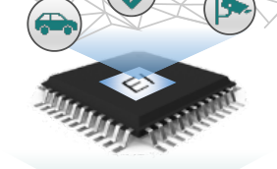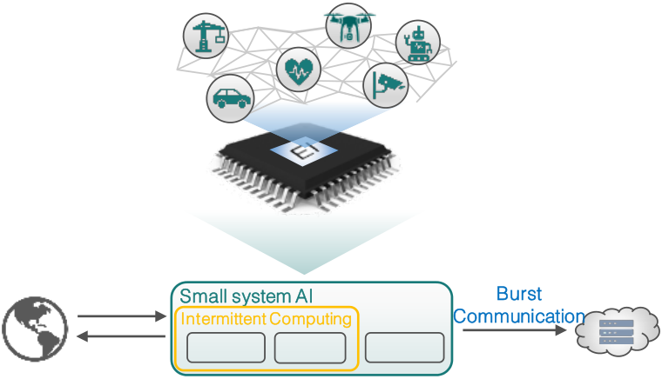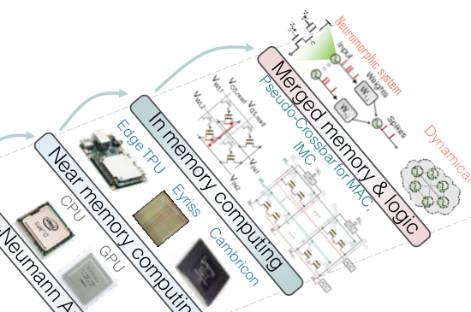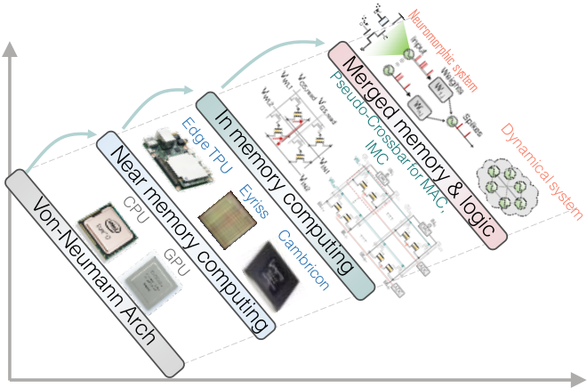

Department Head

sensed. This data needs to be analyzed, reduced and acted upon. Today this data is sent to a central location, the cloud, for analysis. In the cloud, using established computing architectures, data is crunched to provide analytics and services for users based on known business models. This cloud-centric model is not sustainable and will not be capable of meeting the requirements of the smart IoT world as explained in [1]. It is interesting to note that in 1999 at its inception, IoT

Smart Connected IoT

|  |  |
| --- | --- |
| The Engine | Energy-efficient local computing is key for |

Edge Intelligence (EI)

Sensed Raw

Data

|  |  |  |
| --- | --- | --- |
| (audio, image, | Small system AI | Burst |
| temp., etc.) |
| Intermittent Computing | Communication |

|  |  |  |  |  |  |
| --- | --- | --- | --- | --- | --- |
| was defined by Proctor and Gamble’s Kevin Ashton as | Intelligence | Process | Storage | Decision | (Reduced data, |
| Actuation | | | Information, |
| “Sensor-technology enabled computers that observe, | Context-aware) |
| (inference, | | |
| identify and understand the world—without the | learning, control) | | |
| Power-Performance Design Space | | |
| limitations of human-entered data. These computers |
| communicate with each other via the internet.” This |

describes a “smart” system, but due to a lack of capabilities of the available technologies, the

implementation yielded “dumb” IoT devices. This turned the world of IoT into a communication-centric proposition where raw data collected locally by the IoT devices was transmitted by these IoT devices to a central location for processing and analysis.

The semiconductor industry for several decades has revolved around using versatile, pervasively available, programmable CPUs based on the von Neumann architecture with clear (physical and architectural) separation of memory blocks and logic/processing units. These architectures rely on a controller that moves data from cache to the compute element. Preserving the states and the control flow is critical in these architectures. While the von Neumann architecture for constructing microsystems has served us well and continues to be useful, it is proving to be

insufficient to support today’s new computing workloads, more focused on the flow of data and characterized by an overwhelming deluge of data [1], [2]. Today’s and tomorrow’s computing demand new capabilities driven by data centric applications to augment our historical ecosystem. New architectures are needed to serve the demand of smart IoT.

One of the core challenges of many IoT applications is being able to operate in an environment where energy is scarce, and its sources are intermittent. To process massive amounts of data locally collected by these IoT devices with high energy efficiency while maintaining high throughout, the computing hardware will have to overcome energy waste associated with moving data back and forth between separately located memory and logic areas i.e. addressing the “memory wall” and the “von Neumann bottleneck” (speed mismatch of

Energy Efficiency

Computing Performance

Fig. 1 Energy efficient local computing is the key for Edge Intelligence, a key to enabling the vision of a trillion smart connected IoT devices. The power-performance design space for progression of computing hardware is depicted.

memory and logic) challenges. This points toward adopting near memory and in-memory computing (IMC) architectures i.e. moving toward a blurred boundary between logic and memory elements. Memory plays a critical role in these innovative data-flow architectures. The concept of a controller may get challenged because compute occurs by immediate access to the data, as it flows. For example, a mathematical function like a matrix multiplication may occur in the memory. The goal is for the computation to become analogous to a flow where one cannot separate the data flow from the compute. These new architectures need to be considered while delivering continued performance gains at a rate exceeding the one provided by scaling microsystems utilizing the established von Neumann architecture [1], [2], [3].

At the forefront of the data centric computing paradigm is the vision that a trillion, connected, smart edge IoT devices (EI-IoT devices) will be pervasively and seamlessly integrated into the fabric of life measuring physical world parameters. For this to become a reality, Edge Intelligence (EI) is required. EI is the ability to analyze data at the point of data

|  |  |
| --- | --- |
| 2 | IT professional |

collection and make decisions based on that data autonomously, locally at the edge in real time (Fig. 1). The EI ability will lead to unprecedented opportunities for contextually intelligent applications with far-reaching societal implications. Edge intelligence will also ameliorate the communication bottleneck by allowing the communication of information bits rather than the raw data bits [1]. EI requires Artificial Intelligence (AI) to evolve from being performed in the cloud to being executed by “Small-System AI (SSAI)” engines in the smart Internet of Things (IoT) devices at the edge (EI-IoT devices).

SSAI-enabled autonomy in decision making requires a capable engine for these EI-IoT devices. Energy autonomy, required when energy is scarce and its supply intermittent, leads to a special class of EI-IoT devices that will need to rely on Intermittent Computing [1]. Their SSAI engines will operate on harvested energy and have a means to preserve their state when the energy source is depleted [1].

Altogether, if new semiconductor technology capabilities can support the upcoming computing paradigm shift effectively, the sheer number of required semiconductor devices will drive the next stage of exponential growth of the semiconductor industry. This motivates our paper. Innovations at all levels of the computing hierarchy enabled by materials, devices, circuits, architecture, system and algorithms will have to play in concert to deliver new functionalities beyond what is available today [1], [3]. FerroElectronics was introduced as a subfield of electronics based on HfO2 ferroelectric thin films [1], [4]. Paper [4] discussed the wide range of devices from versatile embedded (non)volatile memory elements to compute elements made possible by CMOS compatible HfO2 thin films. This technology shows promise to form the foundation of tomorrow’s in-memory computing paradigm.

This paper addresses the SSAI engine. In-memory computing (IMC) fabrics, new architectures, and memory compute elements based on ferroelectric key building blocks which are compatible with advanced CMOS technology platforms. It will show how ferroelectrics can be leveraged at the circuit, micro-architecture, system, algorithm and software level to deliver autonomy and energy efficiency and provide the performance gains resulting from logic-memory colocation. This paper will argue that FerroElectronics, its building blocks, and particularly the key FEFET (ferroelectric field effect transistor) memory device

with its extreme energy efficiency and functional diversity enables merged logic-memory functionalities, is all important in addressing the needs of these emerging data centric computing paradigms to tackle our modern workloads [4], [5].

APPLICATION DRIVEN HARDWARE

REQUIREMENTS

Currently, GPUs are the main computing units used in a central location, the cloud, to do the computation needed for the neural networks (NNs) used in image recognition applications. They (including TPUs) operate at a compute efficiency of approximately 1 TOPS/W (and are aspiring to reach 10 TOPS/W) while delivering 100 TOPS of performance (Fig. 2). This computing performance level is needed to achieve the required system level accuracy targets. It mainly relies on an array of processing cores with shared memory. In these GPU-based accelerators, weights and inputs/outputs move across graphics processing elements (PEs) accessed from a shared memory. The Multiply-and-Accumulate (MAC) function is performed digitally for the required linear algebra. The compute efficiency tops out at ~1 TOPS/W.

Edge Intelligence’s requirements exceed today’s capabilities. Take for example the case of a micro drone (uDrone) [3], [6]. A uDrone should be capable of doing local computing in order to move smoothly at speed of 10 m/s or higher and to control its movement without getting stalled in the air waiting to decide where to go next. It needs to process images at a data rate of 30 fps or more. To be able to do this, three computing vectors need to be addressed and accelerated: (1) computing for solving perception class of problems, like inference (in ML) using NNs, (2) computing for optimization class problems: particularly, solving large-dimensional optimization problems by the alternating direction method of multipliers (ADMM), by breaking the convex optimization problem into smaller pieces and solving with NNs, etc. This method requires iteration capability and hence relies on local memory capability, and (3) computing to enable in-field learning, i.e. utilizing Reinforcement Learning (RL) as an efficient technique, particularly doing so by a combination of Transfer Learning (TL) and RL (referred to as RL+TL). Efficiently performing RL+TL which requires a clever local memory hierarchy design and perhaps combining different memory computing elements, will be discussed in this paper.

3

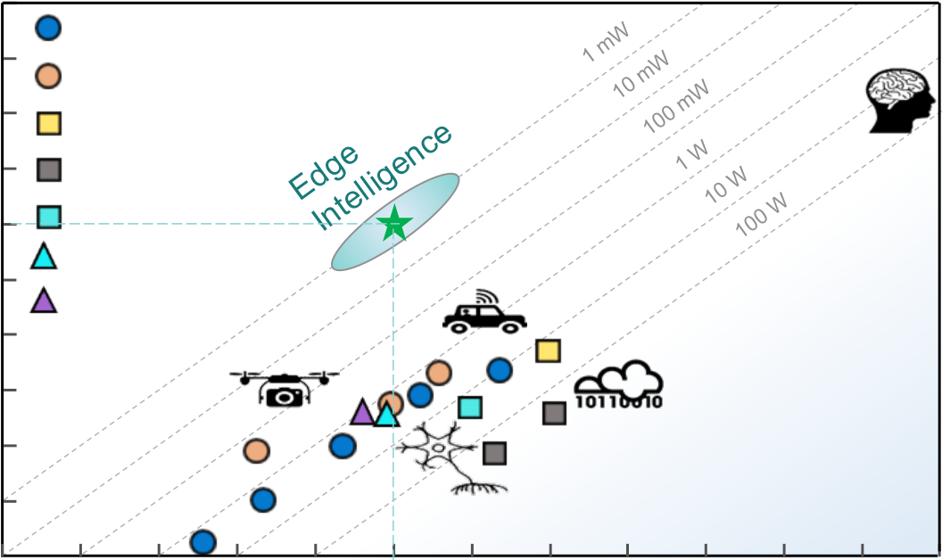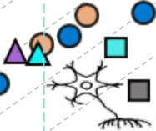

Department Head

|  |  |  |  |  |  |  |  |  |  |  |  |  |
| --- | --- | --- | --- | --- | --- | --- | --- | --- | --- | --- | --- | --- |
| Compute Efficiency (TOPS/W) | 107 | Mobile eye (Autonomous Cars) | | | | 7 nm | 102 | 103 | 104 | 105 | 106 | 107 |
| 105 |
| Movidius (Edge AI drones) | | | |
| Google TPU | | | |
| 103 | Nvidia GPU | | | |
| Baidu XPU | | | |
| Stanford Neurogrid | | | |
| 101 | IBM True North | | | |
| 7 nm | | | |
| 10-1 | 28 nm  28 nm | | | | 101 |
| 65 nm | | | |
| 40 nm | | | |
| 90 nm | | | |
| 10-3 10-5 |
| 10-4 | 180nm  10-3 10-2 | 10-1 | 100 |

Compute Performance (TOPS)

Fig. 2. Compute Performance versus Compute Efficiency with contours of constant power consumption. Edge

Intelligence (EI) requires 1000 TOPS/W with 1 mW power consumption, delivering a performance of 1 TOPS.

To quantify these computing needs, the following should be considered. The uDrone relies on a vision-based navigation capability because it needs to move smoothly at speed of 10 m/s. It will process images at a date rate of 30 fps. Assuming it will use inference for navigation (which means training has happened somewhere else), this uDrone needs to deliver 1.8 TOPS of performance. This number is based on using the average of ResNet-50 and VGG-16 models (parameters and computing), which requires ~10 GMACs per inference in the required NNs. Each MAC corresponds to 2 OPS, so 10 GMACs translates to 20 GOPS. At 30 fps, we need 600 GOPS of performance. Since the uDrone relies on multi-spectral imaging, using 3-frequency imaging the total required computation is 1.8 TOPS for this inference-based image-based navigation. Inference utilizes stationary weights in the NNs. If the uDrone needs the ability to learn in the field, RL for training on-the-fly is needed. RL can use NNs to learn a function approximator. We are assuming that our required RL needs 10 rounds (or passes) and 10 iterations, leading to 100 times more computation than in the case of inference only. The in-the-field learning requirement increases   
 the computation demand a hundred fold from 1.8 to 180 TOPS. With the uDrone being powered by a lightweight battery providing 100mW over a period of 30hours of flight, this means that an engine with a performance of 100 TOPS requires a compute efficiency of 1000 TOPS/W (Fig. 2).

These calculations show that Edge Intelligence may demand delivering to a wide dynamic range of performance, spanning from 1 TOPS to over 100 TOPS. Considering the limited power budget at the edge, compute efficiency of exceeding 1000 TOPS/W would be necessary to deliver our required performance in the small systems to realize the vision of EI (Fig. 2) for low-latency and real-time decision-making ability.

WHY EMBEDDED NONVOLATILE MEMORY?

Various new elements, building blocks and foundational technologies (bottom-up) will be necessary to march toward achieving these high compute efficiencies. IMC is one such foundation. For IMC, a memory compute element in advanced technology nodes is needed because both performance and power matter. Typically, embedded SRAM (eSRAM) is the only memory available to be integrated on the chip in these advanced technology nodes, but not at large densities nor cost effectively. Moreover, SRAM is a volatile embedded memory, at 120-150F2 its bit cell is not dense and for IMC the situation is even worse because extra transistors (8T to 10T instead of typical 6T SRAM) are needed to manage write disturb. In addition, SRAM does not support multiple bits per cell, it is leaky and consumes significant amount of standby leakage power. Furthermore, embedded Non-Volatile Memory (eNVM) is required for our small-system AI to be capable of doing intermittent computing and burst communication. Being in the field

|  |  |
| --- | --- |
| 4 | IT professional |

where sources of energy are scarce and having a SSAI engine capable of operating in the mW regime opens the door for energy scavenging as the main source of energy. Intermittent Computing requires the capability to maintain the state of the compute engine when the energy source runs out. This requires the appropriate architecture and software in combination with eNVM

to store the “state of the compute engine” so the system can seamlessly restart when energy becomes available (Fig. 3).

The EI applications, of which the uDrone case is an example, impose additional requirements on the choice of embedded memory and the memory compute element. Considering that the application should be capable of doing the three defined computing vectors, at least two classes of NN topologies are considered in our discussions. These two NN topologies are AlexNet NN topology and ResNet-50 NN topology. For these two NN topologies, we will discuss the number of weight parameters and the required amount of MACs, assuming that each weight parameter needs approximately eight bits (8b) or one-byte (1B) of memory.

The AlexNet NN model and its variants have been shown to serve EI applications that require solving a combination of perception and optimization problems because this NN topology uses a combination of both convolutional and fully connected layers. It requires ~60MB of memory and a computing performance of ~0.725 GMACs or ~1.5 GOPS. The AlexNet NN topology has 5 convolutional and 3 fully connected layers representing a more balanced NN approach. It requires memory and it relies on compute, but it is not all about computing such that it can be serviced purely by a systolic array of processing elements alone. This topology applies to the uDrone example and for the in-field learning RL+TL using a mix of ~20% SRAM and ~80% eNVM to provide the right memory density, low write energy and high endurance write capable implementation [6], [7].

A dense and hierarchical embedded memory with a mix of volatile and non-volatile capability is chosen to avoid the memory wall problem and the energy cost associated with an external DRAM and FLASH memory combination used in computing solutions typically seen in the cloud. At the edge and in our discussed topology for the uDrone, we need to go beyond stationary weights for inference-only applications. First and for most, we will be requiring a

dense low write energy profile embedded memory solution.

The ResNet-50 topology can be more suitable for perception class problems (deployed in imaging and vision applications) that use a deeper 50-layer NN with 49 convolutional layers and 1 fully connected layer. This NN topology demands more computing and requires less memory. ResNet-50 asks for ~26MB of memory and requires a computing performance of ~4 GMACs or ~8 GOPS. To support both topologies, a computing performance of >10 GOPS and a memory density of >60MB at the NN level are needed. For challenging EI applications like the uDrone, >1 TOPS of performance with embedded memory density of >100MB at low power are required.

FEFETS AND KEY FERROELECTRICS

BUILING BLOCKS OF FERROELECTRONICS

For the data centric smart IoT applications requiring EI, the key features of the memory compute element for the IMC and the memory compute fabric in the memory-centric computing approaches are discussed next. A dense, fast and low energy embedded memory is essential. SRAM although readily available in advanced technology nodes (below 28nm node) by itself is not the desired choice (low density, high cost in area, high leakage resulting in poor energy efficiency). It should be augmented with a denser and equally low energy profile embedded non-volatile memory. Key EI application-driven requirements are: (1) dense embedded memory capacity of >100MB; achieving density metric improvement >4X bits/mm2 based on a single bit per cell compared to an SRAM, (2) cell size of 20-30F2 corresponding to >5X smaller cell size than a SRAM, (3) multiple bits per cell capability, preferably 3 bits/cell, (4) density improvement of >10X per consumed area, for example ~5X by cell size reduction and ~3X improvement by multiple bits per cell for about ~15X improvement (5) symmetric conductance for improved learning capability, (6) high endurance of >1010 cycles as learning needs writing to the memory and not just reading and sensing it, (7) low write energy and in general a low energy profile in the class of fJ/bit, (8) speed in ns range, (9) transistor transconductance allowing for faster read and multibit per cell read, and (10) finally retention which may be traded for higher endurance for improving write performance as needed in IMC operation. A table of eNVMs and embedded memories is captured in Fig. 5 [4], [5]. From an energy, speed and density parameters

5

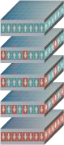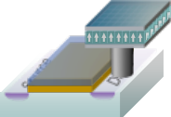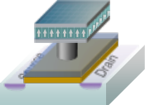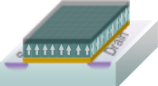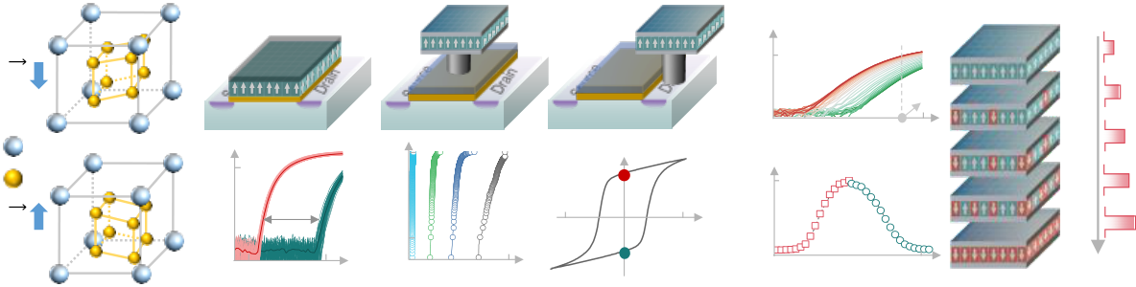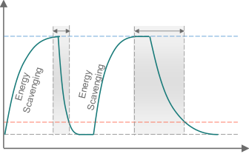

Department Head

|  |  |  |  |  |  |  |  |  |  |  |  |  |  |  |  |  |  |  |  |  |
| --- | --- | --- | --- | --- | --- | --- | --- | --- | --- | --- | --- | --- | --- | --- | --- | --- | --- | --- | --- | --- |
| Ferroelectric HfO2 | | | FEFET | | | | FEMFET | | | | n+ | FERAM | | | Analog States | | | Intermittent Computing | | |
| n+ | Oxide | n+ | | Oxide | n+ | | 10-5 ID (A) | Vread | |
| Energy | Computing | Computing |
| Hf  O | n+ | | Interlayer | | | n+ | **E1** | | |
| p-Si | | | p-Si | -3 | p-Si | | | 10-8 0 1.0 VGS (V)  Symmetric conductance | | | **E2**  **E3** | | |
| Memory Characteristic 10-6 | | | | | | Multibit per cell 100 | | | | PFE(*μ*C/cm2) 20   Pr | | |
| Probability   10-2 | | | | 60 GDS (*μ*S)  0  0 | Pulse num. | 60 |
| ID (A) | | Memory  window | | | |
| -20 | -Pr | 3  VFE (V) | Time | | |
|  |  | 10-9 | | 0 | VGS (V) 1.5 | | **E1**: Power on, **E3**: Power off | | |
| 0 | ID (*μ*A) | | 1.2 | **E2**: Low Energy, stop computing, check-pointing | | |

Fig. 3. FerroElectronics building blocks based on orthorhombic phase ferroelectric HfO2. Ferroelectric devices include: the 1T FEFET, 1T-1C FEMFET, and 1T-1C FERAM. A large memory window and multiple bits per cell are exhibited in FEFET and FEMFET. By harnessing the partial polarization switching in ferroelectric HfO2, intermediate analog states can be created and utilized as synaptic weight cell. Symmetric weight tuning characteristics can be achieved in FEFET. Intermittent Computing uses eNVM to store the computing state.

point of view, a memory compute element based on century-old physics and a decade-old newly found ferroelectric material stands out for serving the requirements of EI. It also satisfies the critical attribute of being process compatible with advanced technology nodes, so it can be used in concert with eSRAM and scaled logic transistors.

Ferroelectricity has been around for 100 years. In fact, for decades there have been commercial products using PZT-based Perovskite Oxide Ferroelectric Capacitors (FeCAP) in a 2T-2C FERAM cell configuration (some applications use 1T-1C FERAM cell configuration) inside memory arrays that are used as non-volatile embedded memories for microcontrollers and digital signal processors as well as stand-alone NOR memory solutions in niche applications like e-metering and RFIC [1], [4]. FERAM solutions based on Perovskite Oxides have not scaled beyond the 130nm technology node. They suffer from a destructive read, are slow and sensing for read requires an accurate reference which adds complexity to the memory array design, typically requiring the larger 2T-2C cell configuration and it impacts array efficiency. These commercial FERAM solutions have shown very good endurance of >1014 cycles making them well-suited for DRAM type application (note that the FERAM operation is like a DRAM’s with a destructive read, consuming some extra endurance cycles for re-writing, but with a longer retention, lowering the refresh burden at the cost of not being as dense as DRAM). The film thickness for PZT-based FeCAP is large at 70nm. This is a major reason why the technology has not scaled beyond 130nm. The cell size is at best 3X smaller than a SRAM’s at that 130nm node. Another reason for the niche status of this technology is the fragile nature of the PZT film which makes it hard

to integrate in a standard CMOS process flow. Higher spontaneous and remnant polarization for a 1T-1C FERAM architecture utilizing 1C FeCAP are required.

Ferroelectric-based devices have the best energy profile, primarily because of their physics. The polarization state changes by applying the small amount of energy associated with moving an atom by a distance less than an angstrom. This consumes less energy than needed to program charge-based devices and much less than needed to program magnetic, spin, phase change or filament forming (RRAM) devices [4]. Our quest for the next eNVM technology that meets all the requirements of our EI applications leads us to a novel thin film ferroelectric material used to create a device called FEFET or Ferroelectric Field Effect Transistor. The FEFET device has been the subject of research lately because of the recent breakthrough observation of ferroelectricity in doped Hafnium dioxide (HfO2) [8], [9], an oxide that is compatible with leading edge high--metal-gate (HKMG) CMOS process flows. HfO2-based ferroelectricity and related materials (such as HZO i.e. Zr doped HfO2 also shown as Hf1-xZrxO2 where x<1) have opened the path to FEFETs becoming the preferred memory compute element to be used for IMC [1], [4], [5]. Hafnium dioxide (HfO2) has been widely used in high--metal-gate (HKMG) logic transistors since mid-2000 [2], [4]. Therefore, this compatibility and the availability of processing tools can unleash the promise of FEFETs in high volume semiconductor manufacturing [1], [4]. FEFETs have similar scalability trends to state-of-the-art logic HKMG/FinFET transistors, which are scalable down to sub-10nm nodes. FEFETs can be integrated in FEOL with a greatly reduced mask count of ~2. FEFETs have already been integrated in 28nm planar bulk CMOS and 22nm fully depleted planar silicon-on-

|  |  |
| --- | --- |
| 6 | IT professional |

insulator (FDSOI) CMOS platforms as an embedded memory technology [4], [9].

FEFETs will be critical in addressing the needs of the data centric computing paradigm based on their extreme energy efficiency, high density and diverse merged logic-memory functionalities. For example, FEFETs may prove to possess the ideal analog weight cell characteristics (critical for IMC). Ferroelectric devices operate based on polarization switching dynamics. In FEFETs, the intrinsic ferroelectric polarization dynamics are strongly coupled to the conductance state of the underlying transistor channel (Fig. 3) [4], [5]. This device relies on voltage (electric field driven) switching and is not based on current switching like many of the proposed emerging eNVM solutions.

The FEFET is a three-terminal device having a transconductance gain that allows for a wide range of circuit topologies and designs that can leverage its unique ferroelectric physics, serving the needs of both traditional and emerging computing applications. One aspect of Ferroelectric physics in FEFETs is its plasticity based on the stable, partial switched states in the ferroelectric film of the FEFET, programmed by sub-coercive voltages (Vc). In the FEFET, plasticity leads to multi-states, non-volatile operation, allowing multiple bits per cell capability as shown in Fig. 3. Transconductance gain eases reading the multiple bits per cell. Another interesting characteristic, useful for learning, is the symmetric conductance behavior that can be achieved in the FEFET (Fig. 3).

The energy profile of the FEFET is the best-in-class among all non-volatile memory technologies (Figs. 3 & 5 and approaches the realm of the volatile eSRAM. The transistor action in FEFETs, which is not available in other two terminal emerging (resistive) eNVM memories, allows not only for a fast, non-destructive read but also enables unique, efficient and creative cell, array and circuit designs with a small cell size (10-30F2 depending on the application). The write operation in ferroelectric devices can be extremely fast, taking less than 1ns. It is the FEFET’s transconductance that makes also the read fast.

FEFETs are a work-in-progress and are being heavily researched to address some of their challenges: variability (a problem toward achieving high density arrays), endurance improvement requiring engineering of the interfacial oxide layer (IL), lowering of the HZO film thickness, and scaling of the FEFET device size. To date, endurance cycling performance of state-of-

the-art FEFETs have been limited to the range of 105-109 cycles [4]. Although this endurance is better than the endurance of most emerging memory alternatives, it is poor compared to the near unlimited endurance of eSRAM. Since IMC needs >1010 endurance cycles, improving endurance is the subject of research with alternative device structures being considered (for example the FEMFET shown in Fig. 3, in which the IL layer is eliminated). Improving the design of the gate stack and the IL layer between the FE layer and transistor channel of the FEFET are also topics of intense research. The IL layer is the main cause of the limited endurance performance of the FEFET. The FE layer by itself if sandwiched between two metallic layers will have good endurance similar to the 1T-1C FERAM [4]. Retention in FEFETs is good and meets the typical 10 years duration specification. It is important to note that retention may be traded for improving endurance for performing IMC and in-field learning in EI-IoT devices.

FEFETs possess a set of key characteristics that are particularly important for creating either dense embedded memories for standard embedded memory applications or more importantly toward the memory compute element for IMC to accelerate computation for example for NNs (providing multi-state weight cells or so-called analog synapses [4]). Multi-bit operation with 2-8 bits per cell (4-256 levels), in the order of 100-fold conductance modulation, fast ns write time, as well as linear and symmetric conductance (potentiation-depression) leading to higher accuracy computation were discussed in [4]. An FEFET can also act both as the selector and the non-volatile memory element in a Ternary Content Addressable Memory (TCAM) leading to the smallest footprint TCAM cell with just two transistors. Content addressable memory cells can be efficiently used for pattern matching applications, for fast and parallel database searches and in finding match locations. Cypress semiconductor used non-volatile SRAM (combining SRAM and SONOS eNVM) to make TCAM solutions for network packet routing, but that TCAM cell had over 10 transistors with a very large footprint [1]. Non-volatile logic and fast data back-up and wake-up circuits for intermittent computing can also utilize combinations of these ferroelectric features and characteristics [4].

The use of ferroelectric devices expands significantly beyond memory applications and today includes negative capacitance transistors for ultra-low power, high performance logic technology, artificial

7

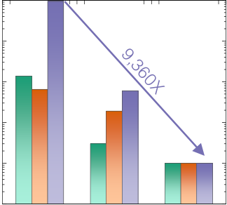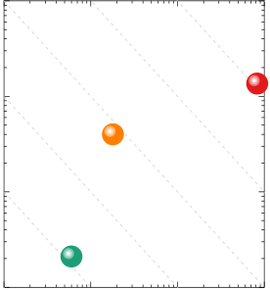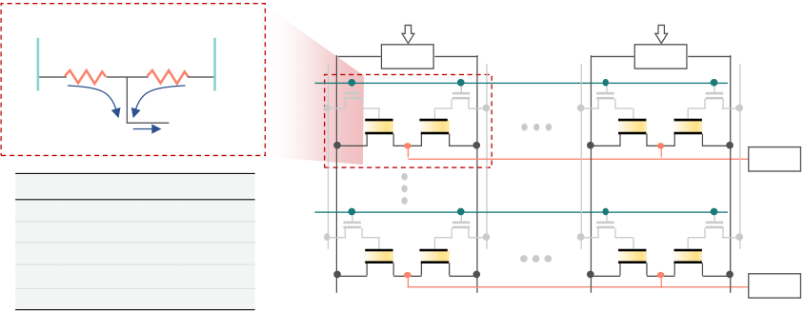

Department Head

|  |  |  |  |  |  |  |  |  |  |  |  |  |  |  |  |  |  |  |  |  |  |  |  |
| --- | --- | --- | --- | --- | --- | --- | --- | --- | --- | --- | --- | --- | --- | --- | --- | --- | --- | --- | --- | --- | --- | --- | --- |
| VREF-ΔV | | VREF+ΔV | | | GL1+ | IN1 | GL1- | GLN+ | INN | GLN- | | Energy (J) | 10-2 | | | | Normalized Parameters | 104 | Delay | Energy | Energy Delay Product | SRAM | FEFET |
| G+ΔG | | G-ΔG | | | DAC | DAC | Baseline | | | |
| 103 |
| WL1 |
| BL1+ | I1+ | I1- | BL1- | |
| 10-3 | SRAM IMC | | |
| ADC | | 102 |
| I1=-ΔV•2ΔG | | |
| MLC | | eSRAM | | FEFET | WLM | BL1- | BLN+ | BLN- | ADC | 10-4 | FEFET IMC | | | 101 |
| No | Yes | |
| Nonvolatile | | No | Yes | | 100 |
| Energy/bit | | 1~10 fJ | ~1 fJ | |
| Latency | | <1 ns | ~1 ns | | BL1+ | 10-5   10-7 | | 10-6 10-5  Delay (s) | 10-4 |
| 10-1 |
| Endurance | | 1016 | 105-109 | |
| Baseline | | |
| IMC | IMC |

Fig. 4. In memory computing with FEFETs. By using the FEFET conductance as the neural network weight, matrix

vector multiplication can be accelerated in the analog domain. IMC computing based on FEFETs provides a 9,360X

improvement in energy-delay product compared to the von Neumann “Baseline”.

neurons for spiking neuronal networks (SNNs), and circuit primitives for stochastic computing [4]. All are beyond the scope of this paper. However, we will briefly elude to using ferroelectric-based coupled oscillatory networks for continuous time dynamical systems in our outlook section [4], [10].

The FEFET is a foundational technology building block in FerroElectronics. However, FerroElectronics builds on additional ferroelectric-based devices and technologies for logic, analog and RF transistors [1], but these are not the subject of this paper. The FEFETs provide desired features for the alternative computing paradigms. FEFET technology and the broader FerroElectronics are important elements for realizing EI, the bottom-up approach path.

IN-MEMORY COMPUTING BASED ON

CIRCUITS WITH FEFETS

This section describes building the arrays, memory compute fabric, corresponding circuits, processing elements, and the cores for the compute engine for EI using the FEFET memory compute element.

The idea of in-memory computing (IMC) is not new. Back in the 60’s, even von Neumann himself was thinking about processing in memory. However, the question of what processing should be performed in the memory was not resolved then. Today, with Data-centric computing demands and in particular with the need for vector multiply and add operations, it is worth revisiting IMC for small systems that need to process large amounts of data at the point of collection efficiently with low latency and high speed (with high throughput). IMC is essential in memory centric computing. IMC reduces the movement of large amounts of data and hence addresses the memory bottleneck challenge. IMC brings the MAC operation into the memory. The way IMC works is that the vector

matrix multiplication (VMM) is conducted in a parallel manner: input vectors activate multiple rows in parallel in the memory. The input vectors are multiplied by the memory cell conductance (i.e. multiplication or dot-product) that contains the weights creating a partial sum on the bitline column where the current of the bitline column represents the analog MAC value in VMM. IMC needs Analog-to-Digital Converters (ADC) at the periphery of the array in order to convert the analog MAC/VMM on the bitline to binary bits for digital processing in the small system. The parallel nature of conducting the math saves energy, but several trade-off parameters such as the energy, array area efficiency, pitch-matching, types of ADCs used and the area and power consumed by the required ADCs (and extra complexity of mixed signal design used) need to be considered for IMC.

Next the design of the memory computing fabric delivering a more efficient IMC needs to be addressed. What memory compute element should be used?

SRAM is available and has been used by itself for IMC with mixed results. The throughput is high, the read it fast, and the write energy of this charge-based embedded memory solution is good. However, this memory is not dense enough (it consumes a large area in very expensive silicon on advanced technology nodes) for the workloads of interest in the data-centric systems utilizing IMC, for example storing the weights for doing inference. SRAM leakage is high favoring the use of SRAM for systems that are computing with a high activity factor in order to amortize the leakage cost/penalty of the memory. SRAM does not support multiple bits per cell. It is based on 1 bit/cell and to achieve higher precision it needs to add them, using thermometer coding. Capacitive banks (based on SAR ADC topology) add to its complexity (capacitive matching and offset cancelation) and add to the cost.

|  |  |
| --- | --- |
| 8 | IT professional |

SRAM IMC is based on mixed signal design and it is more efficient than digital-only implementations. It targets lower precision applications and the periphery circuits are complex. These issues lower the array efficiency for IMC. Particularly it will be difficult to encode inputs in voltage or time. This limits SRAM to toy and smaller problems with a low number of weigh parameters. SRAM IMC is mostly targeted for binary NNs based on XNOR/XOR with low precision. Since multiple wordlines are activated simultaneously, read disturb is a fundamental issue. A bitline discharge in the SRAM array, which is required for high dynamic-range readout, threatens to write-back into the cell causing destructive read. SRAM IMC happens locally on the bitline as we explained earlier (and it requires ADCs). A better approach is to leverage the SRAM’s strengths and augment it with a dense eNVM [1], [4], [6], [7]. Based on our applications’ requirements, >100MB memory capacity is required, suggesting utilizing a mix of 20% SRAM (20MB) and 80% dense eNVM (80MB) [6], [7].

Referring to the three vectors of computing described earlier, more than computing for accelerating NNs (e.g. CNNs/DNNs) is needed. Other statistical ML algorithms for supporting other linear algebra kernels (beside the covered vector matrix multiplication) may not be as complex as deep NNs. So, near-memory computing using embedded memory (however, not in 2.5D HBM style systems deployed in the cloud) may be used. For example, solving the optimization problems encountered in the case of autonomous uDrones relies on iterative and distributed architectures. One such standard algorithmic approach is ADMM which is based on local computing and iterative communication (computing a result, communicate and iterate on it) in these distributed array architectures. Studies addressing where the energy goes in systems designed for ADMM tasks show that the consumed energy is almost equally distributed between computing, communication and memory operations [12]. This shows that pure systolic arrays of processing elements using a predetermined dataflow may not be suitable for solving optimization class problems. Rather, processing units used for optimization should be connected with their immediate and farther away neighbors for consensus for determining global optimization in ADMM as shown in [12] using a Network-on-a-Chip   
 (NoC) with an 8-neighbor hierarchical multicast network based on asynchronous communication and circuits with a 4-phase handshake

protocol. Furthermore, optimization class problems will require higher bit precision in the compute stages and should support a programmable bit precision and data movement for the iterative algorithms.

Most AI solutions based on ML and accelerated computing for matrix multiplications for NNs can be modified to use positive numbers only, which simplifies the math and implementation. To address the need of our three computing vectors and solving optimization class problems requires that both positive and negative operands are handled. This capability of doing the math with both positive and negative numbers will allow serving a wider range of useful algorithms. However, it will require designing a special array [11] with devices to emulate positive and negative operands, as well as appropriate peripheral circuits as shown in Fig. 4. This figure shows using a pseudo crossbar with a 2T cell. What memory element would be most suited in this approach?

Most emerging eNVM solutions are based on resistive elements typically using a two-terminal 1R resistor element forming a 1T-1R memory cell that is deployed in crossbar resistive arrays. However, the FEFET can be a memory compute element in the proposed 2T cell configuration. Building a large array from FEFETs for IMC, doing computing and using them for EI applications will require working on lowering variability and increasing the endurance of the

FEFETs. We described earlier FEFET’s potential capability for being a fJ/bit energy class with ns speed embedded eNVM for IMC. Moreover, the FEFET for our proposed 2T-cell configuration has a small cell size of ~30F2 which is ~4-5X smaller than a SRAM cell size. Enabling multiple bits per cell, let’s say 3 bits/cell where the FEFET transistor gain plays a key role in distinguishing between the states also contributes to a higher overall density of ~15X compared to same technology node eSRAM. FEFETs can operate at low voltage and are compatible with advanced technology nodes and hence can be integrated next to the embedded SRAM and advanced logic transistors with minimal extra masks. These listed characteristics and what we discussed earlier make FEFETs an ideal solution toward fulfilling our three asked for computing vectors for EI. The FEFET enables a memory compute element, leading to an IMC fabric, building a unit to go inside a core, and then configuring many cores with local memories as per a more capable data flow architecture while allowing for communication among neighboring cores to solve a broader scope of

9

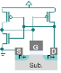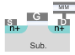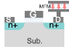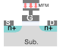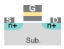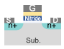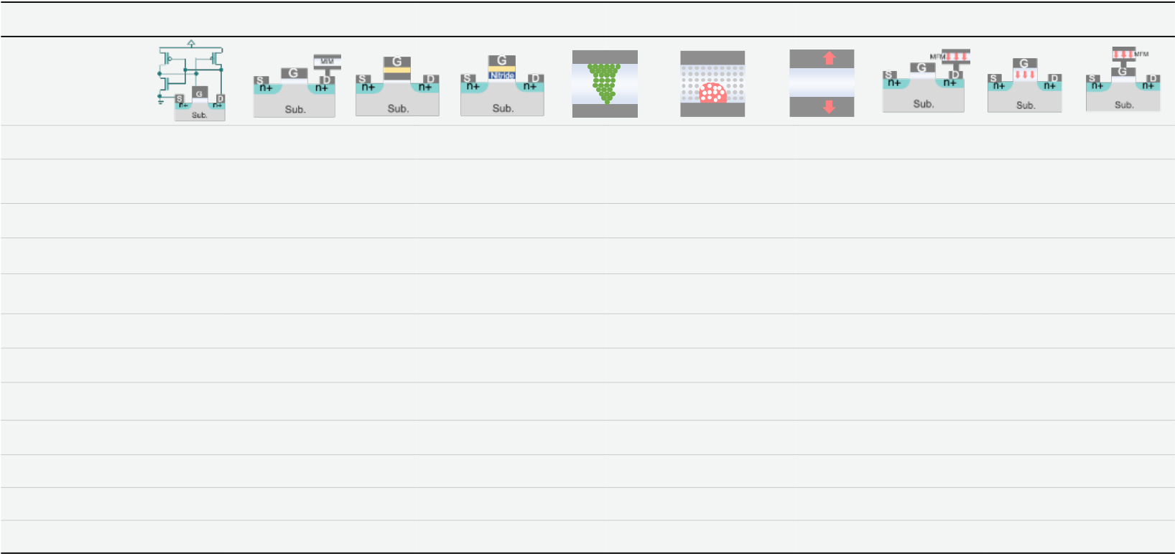

Department Head

|  |  |  |  |  |  |  |  |  |  |  |  |  |  |
| --- | --- | --- | --- | --- | --- | --- | --- | --- | --- | --- | --- | --- | --- |
| eSRAM | | | | eDRAM | FG Flash | SONOS | ReRAM | PCM | STT-MRAM | | FERAM | FEFET | FEMFET |
| Structure | | | | | 1.5T | M | | M  Phase change | | M | 1T-1C | 1T | 1T-1C |
| M | | M | M | |
| Cell structure | 6T | | | 1T-1C |
| 2T | 1T-1R | 1T-1R | 1T-1R | |
| Mechanism | Cross-coupled | | | Charge | Charge | Charge | Filament | Phase | Spin transfer | | Polarization | Polarization | Polarization |
| inverter+charge | | | on capacitor | on FG | in nitride | formation | change | torque, magnetic | | switching | switching | switching |
| MLC | No | | | No | Yes | Yes | Yes | Yes | No | | Potentially | Yes | Yes |
| RON/ROFF ratio | | N/A | | N/A | >104 | >104 | 10-100 | 10-100 | <10 | | N/A | >104 | >104 |
| Status a | Availableb | | | Developmentc | Availableb | DevelopmentcDevelopmentcDevelopmentcDevelopmentc | | | | | Availableb | Researchd | Researchd |
| Integration node 7nm FinFET | | | | 22nm FinFET | 40nm | 28nm HKMG | 22nm FinFET | 40nm | 22nm FinFET | | 130nm | 22nm FDSOI | N/A |
| Cell size | 120-150 F2 | | | 40 F2 | 50 F2 | 60 F2 | 60 F2 | 60 F2 | 50 F2 | | 50 F2 | 20-30 F2 | 30-40 F2 |
| 13+ | 5+ | 3+ | 3+ | 3+ | | 2-3 | 1 | 3+ |
| Additional masks | | | 0 | 5+ |
| Energy/bit | ~1 fJ | | | ~1 pJ | 100 pJ | 10 pJ | >10 pJ | 100 pJ | >10 pJ | | ~1 pJ | ~1 fJ | ~10 fJ |
| Latency | <1 ns | | | >10 ns | 0.1-1 ms | 10-100 ns | <100 ns | <100 ns | >10 ns | | >10 ns | ~ 1 ns | 10 ns |
| Endurance | 1016 | | | 1016 | 104-105 | 104-106 | 105-107 | 105-107 | 106-107 | | >1014 | 105-109 e | 1010 |
| Retention | Volatile | | | Refresh | 10 yrs | 10 yrs | 10 yrs | 10 yrs | 10 yrs | | 10 yrs | 10 yrs | 10 yrs |

a “Status” row is added to distinguish results for the solutions that are in manufacturing phase and production compared to developmen t or research phase.

bAvailable - All the parameters are based on the reported data on memory macro in production and in manufacturing   
c Development - The parameters are based on memory macro data that is still under development, not in high volume manufacturing   
dResearch - The parameters are based on memory device data that is still being researched. Also, there is a difference between macro and array results versus device level results.

e The endurance of FEFETs are under research to increase performance >1010 cycles [4].

Fig. 5. Comparison table of ferroelectric devices with other embedded (nonvolatile) memory devices. Ferroelectric devices are advantageous in terms of energy-efficiency and overall balanced performance [4], [5].

computing problems. Beyond fixed flow NNs for vision and perception (in today’s systolic array data-flow architectures) this provides a path toward solving optimization with ADMM.

Many factors need to be considered in designing circuits and IMC arrays: cell size, cell configuration (more flexible positive and negative operands with a differential 2T FEFET cell configuration without impacting peripheral circuits), number of bits/cell, symmetric potentiation/depression for higher accuracy computation, BL capacitance, number of cells per BL, number of rows and columns, number of activated rows for IMC, DAC and ADC resolutions, topology, type of ADC, and circuit style (requiring mixed signal circuit design) for IMC readout and sensing. A careful analysis of the circuit simulation of the full integrated circuit chip using the measured FEFET device parameters based on 28nm HKMG technology in [11] compared three chip implementations of systems for solving iterative convex optimization problem by ADMM via least-squares-minimization; (1) a digital von Neumann architecture implementation based on ALUs and embedded SRAM (Baseline), (2) an SRAM-based 6T-cell IMC implementation (SRAM-based IMC), and (3) an FEFET-based 2T-Cell, in pseudo-cross-point array for IMC implementation (FEFET-based IMC). The

results are shown in Fig. 4. All three parameters: Energy, Delay and Energy-Delay Product (EDP) were better for implementation number (3), i.e. the FEFET-based IMC. In fact, the FEFET-based IMC consumes 65X less energy than the digital von Neumann baseline and 19X less energy than the SRAM-based IMC. The EDP for the FEFET-based IMC is ~9,400X lower than the EDP for the digital von Neumann baseline and 60X lower than the EDP for SRAM-based IMC. Note that the SRAM-based IMC occupies >3X larger silicon area than the FEFET-based IMC implementation. Exploring the design space shows that for parallel throughput computation using 12-bit DAC and 14-bit ADC with 3 bits/cell, the FEFET-based IMC implementation results in the lowest energy and compute time. Using higher than 3 bits/cell increases the overhead and when the DAC resolution increases, a higher ADC resolution is needed, increasing the energy consumption. Device variability was accounted for in these simulations.

The improved efficiency in computing achieved by the FEFET-based IMC was utilized for solving iterative convex optimization problems by ADMM via least-squares-minimization in two applications: (1) Constructing signal from 1D EEG and (2) Recovery of CT (Brain Computed Topography which is relevant for MRI) images used in medical imaging applications.

|  |  |
| --- | --- |
| 10 | IT professional |

The fidelity of reconstruction process increases as the sub-space dimension increases because the FEFET-based IMC has more computing capability. This enables real-time reconstruction of the data in the field at low-power consumption. Furthermore, it is worth mentioning that solving an iterative algorithm like ADMM in the dataflow architecture resembles a hardware emulation of a distributed and discrete-time dynamical system that will be discussed later.

For these imaging applications, accuracy is a system-level metric. A similar exercise for the uDrone application would use a different metric like collision avoidance as a key system-level metric. A uDrone uses computing for path finding, mapping, depth, localization/SLAM, and control in addition to vision-based navigation. The kinds of circuits and arrays we described for the FEFET-based IMC can help doing more computation for these functions and algorithms.

SMALL-SYSTEM AI AND THE ENGINE FOR

EDGE INTELLIGENCE

The engine for EI should be more than a simple inference engine. Perception and optimization class problems (model-free and even model-based), and ultimately in-field learning by RL for autonomy (for uDrone applications) all need to be handled by such an engine.

A small-system AI engine should be capable of handing the real-time low-latency learning in the field through RL+TL using a combination of eSRAM and FEFET memory. Learning is critical in the case of uDrones if there is no GPS coverage. When the uDrones need to be autonomous, providing a means to learn by interacting with their environment is critical and challenging, since the uDrone needs to move seamlessly at a reasonable speed of 10 m/s. In that case, model weights need to be updated frequently (for learning) and in a short amount of time with a latency of <10 ms. RL can be viewed as a form of learning by trial and error based on reward mechanisms. Learning places a demanding burden on write time, write energy and endurance cycling performance of the embedded memory solution used in IMC. This explains why dense FEFET’s potential for fast ns write time at low fJ/bit write energy with an improved endurance of at least 1010 cycles is a game changer for these learning applications. eSRAM and magnetic/spin-based STT-MRAM were used in a memory hierarchy for RL in systems for uDrones by mapping the algorithm carefully into to this memory hierarchy [6]. The

algorithm utilizes both convolutional and fully connected layers. The fast and changing fully connected layers use eSRAM while convolutional and slow changing fully connected layers are placed in denser eNVM. In the case of [6], the choice of eNVM was STT-MRAM. The write time (latency) and write energy of this choice of eNVM determines the performance of the system and is limited by the magnetic/spin technology capability; although this hierarchical approach allowed for an overall improvement in speed of the uDrone by allowing processing performance at a higher data rate measured by fps, but it did not meet what is needed for 30 fps at 10 m/s and without any loss in system-level accuracy metric. Using FEFET-based eNVM and moving to more advanced technology nodes will significantly improve the performance of such small systems for these applications.

If more computing capability is needed for the uDrone application for path planning, mapping, depth, localization/SLAM, and control in addition to the vision-based navigation, then an FEFET-based IMC provides the more computing required. The uDrone example is an interesting platform for exploring various compute demands such as (1) model-free, learning-based statistical solutions by NNs, etc. and (2) Model-based solutions by the potential fields approach utilizing various linear and non-linear processing units.

Therefore, capabilities enabled by new Ferroelectric-based materials and devices such as the FEFET-based IMC circuits will be key to realizing small-system AI engine’s computation demands. This goes beyond current research in curating data, pruning, compression, condensing the weights or techniques for

tweaking the precision based on today’s technology features that have been widely discussed and continue to be explored in the literature [2], [3].

Going back to today’s solutions (e.g. GPU engine) operating at an energy efficiency of 1 to 10 TOPS/W and considering the gains in delay reduction by a factor of ~140X and improvement in energy efficiency by a factor of ~65X for the FEFET-based IMC as shown in Fig. 4, the system performance compared to these digital von Neumann architecture (Baseline) solutions can be enhanced by implementing an IMC architecture. The results of these improvements make it likely that the target of >1000 TOPS/W compute efficiency with a performance dynamic range of 1 to 100 TOPS for a corresponding power range of 1 to 100 mW as shown in Fig. 2 is feasible for an FEFET-based IMC solution

11

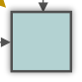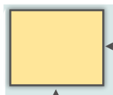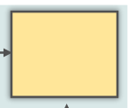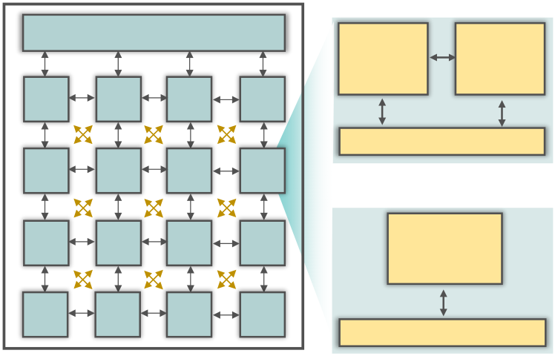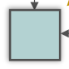

Department Head

that can be exploited by EI-IoT devices. In comparison, central systems in the cloud deliver >100 TOPS of performance at much higher power consumption of >100W. However, it will require pushing research vectors in all scales from materials, devices, circuits, architecture, and systems. Incorporating both bottom-up and top-down approaches to achieve the efficiency.

ARCHITECTURAL FEATURES OF THE

PROCESSING ENGINE

Till this point, we discussed how FerroElectronics, a bottom-up approach viewpoint, can enable much needed efficiency and performance improvements for EI. Let’s also look at architecture and software from a top-down perspective.

|  |  |  |  |  |  |
| --- | --- | --- | --- | --- | --- |
| PE | Global Buffer | | PE | Near Memory Computing | |
| Memory | Logic  Datapath |
| PE | PE |

Control Unit

|  |  |  |  |
| --- | --- | --- | --- |
| PE | PE | PE | PE |

In Memory Computing

|  |  |  |  |  |
| --- | --- | --- | --- | --- |
| PE | PE | PE | PE | Processing |
| PE | PE | PE | in Memory |
| PE |
| Control Unit |

Fig. 6. Architecture of computing hardware supporting near memory and in memory computing.

Architecture plays a key role in achieving the goals Fig.4. Architecture of In-memory computing   
of the small-system AI engine solutions deployed for the Edge Intelligence applications. So far, the architecture has evolved from Many Cores to Domain Specific Architectures (DSA) with Accelerators and ASIC (SoC) implementations in 2.5D heterogeneous integration for near memory computing. Furthermore, Data-Flow Architectures are deployed based on a systolic array of processing elements where pre-determined data flow paths are being implemented with shared memory, inching their way toward Near-Memory Computing implementations. The next phase in architecture enhancement will be re-visiting and implementing In-Memory Computing (IMC) with a dense and low-energy profile embedded memory to eliminate the “memory wall” problem, providing more energy efficient higher compute performance needed to move toward in-field learning. Such architectures are shown in Fig. 6 and are discussed in greater details in [3]. These architectures will be able to support the 3 vectors of computing described earlier in this paper.

Data-flow architectures with arrays of systolic processing elements have been deployed and one could conceive moving toward IMC using other resistive memory elements, but we described its challenges earlier. However, implementing these modified data-flow architectures with our memory compute fabric in IMC, adopting new Ferroelectric-based eNVM in the form of a FEFET memory compute element, in conjunction with eSRAM to be used in the architecture shown in Figs. 4 and 6 can deliver the performance and efficiency we discussed in this paper. Small systems designed based on these technology features can solve interesting EI problems. Distributed optimization shows an interesting class of algorithms where computation, communication, and memory storage are almost equally important in terms of power consumption [12]. In-field learning’s computational demand will be served by IMC, employing TL+RL by using an eSRAM and FEFETs memory hierarchy [6], [11].

The path toward Merged Logic and Memory and the Computational Memory concepts will lead to a future when we create MANNs, RNNs, dynamical systems based on FerroElectronics computing foundational capabilities.

OUTLOOK AND A PATH TOWARD THE

FUTURE

A small-system AI engine is at the heart of the much-needed efficient electronic hardware for Edge Intelligence that enables the explosion of data centric computing applications. This will in effect fuel the next wave of exponential growth of the semiconductor industry. We have explained in this paper why FEFET technology and the broader FerroElectronics are important elements for realizing EI and how they fit in a data-flow architectural scheme with IMC.

Achieving a computing performance at the very high compute efficiency of 1000 TOPS/W based on FerroElectronics allows minimizing the system-level energy consumption by utilizing enough local computing to minimize the communication needs in these smart small systems [1]. Local computing lowers the burden of communication. Because transmission energy per bit has not been successfully reduced below 1 nJ/bit and because of the bandwidth problems, communication needs to be kept to a minimum and reserved for valuable information bits. The solution path points to using in-memory computing consuming

|  |  |
| --- | --- |
| 12 | IT professional |

1 fJ/bit to convert raw data to valuable information bits, aggregate these information bits and communicate them in bursts while being aware of the quality of the channel, i.e. communicate when channel is good, further lowering the communication channel energy (Fig. 1). Note that by going from data to information using local computing reduces the number of bits by a factor of 10,000X [1].

A recent paper [13] shows how computing and communication can be managed by a small-system AI engine doing IMC to autonomously optimize the system energy consumption. The engine is implemented by a SoC that includes an image processor and a digitally adaptive radio for communication along with an IMC-based controller implemented in 65nm technology. It emphasizes the point that AI can be applied even for the management task of determining how much computing versus communication should occur. The problem is a multi-variable system level power optimization challenge [13]. This paper is an interesting proof of concept, but the compute performance efficiency is only at about 1 TOPS/W mainly constrained by the technological features and the limited capabilities supported by the 65nm node. To improve the efficiency by greater than 2 orders of magnitude while delivering much improved performance that can be allocated for computing, for in-field learning, for doing in-device in-hardware security solutions, FerroElectronics Computing is a promising answer.

In near and in-memory computing approaches, logic and memory are architecturally close but physically need to be designed explicitly. Thinking beyond, a dynamical system approach should be explored. In dynamical systems, much like the human brain, logic and memory are not physically separated. In a dynamical system, computation evolves as a flow of physical variables like voltage, current, phase etc. that interact with each other in a coupled system. In future machines deploying a dynamical-system-based compute engine, the states and the compute are not physically separable. States appear as analog variables (current, voltage, phase, etc.) which evolve based on physical rules and computation is analogous to a flow. This can be thought of as the ultimate form of merged logic and memory where states evolve autonomously based on the computation that we are performing (as per flow of the data). For example, in a dynamical system, we can set the phase of an oscillator to follow the function that we want to differentiate, and then

observe the corresponding frequency (frequency = d/dt(phase)). Phase and frequency are not separable here - one is the result of another. However, if we think of phase as a state variable, then frequency is the output of the computation. Ferroelectric-based FEFET-based oscillators (as part of FerroElectronics) for dynamical systems can create such future machines [4], [5], [10].

In closing, this paper discussed how combining a bottom-up ferroelectric based material and device approach (Fig. 3) with a top-down architecture choice (Fig. 6) enabled an in-memory computing (IMC) capability to achieve the results shown in Fig. 4 and the future SSAI engine to meet the compute performance and efficiency requirements of EI (Fig. 2). The application-driven discussions in this paper based on looking at the requirements from both bottom-up and top-down identified several technical challenges and research vectors covering all scales - materials, devices, circuits, design, architectures, and implementation of an engine to realize the vision of EI. The archetype of Artificial Intelligence (AI) in small efficient systems is a key enabler for a wide range of applications that require the devices to operate autonomously and sustainably in challenging and energy-constrained environments, projected to reach a trillion Internet of Things (IoT) devices. EI enables smart devices to sense, analyze, decide based on and act on locally collected data, and send information to the cloud, rather than relying on the cloud to analyze and decide based on transmission of raw locally collected data that is sent to the cloud. Turning sensed data into information for actionable intelligence locally requires a careful balance of energy-efficient computing and communication demands in a small-system. The system is operating at the intersection of Moore’s Law and the Shannon-Hartley Theorem. The carful trade-off results in minimized system energy consumption. Ferroelectric building blocks enable a new capability and ushers in the era of FerroElectronics, paving the way for doing in-memory computing in data-flow architectures, improving compute efficiency by 1000X, satisfying the requirements of Edge Intelligence. This will allow deployment of many EI-IoT devices based on the small-system AI engines for a range of smart applications that will drive the next phase of the semiconductor industry growth.

○ REFERENCES   
[1] A. Keshavarzi and W. Van Den Hoek, “Edge

13

Department Head

Intelligence-On the Challenging Road to a Trillion Smart Connected IoT Devices,” IEEE Des. Test, vol. 36, no. 2, pp. 41–64, Apr. 2019.

[2] S. Salahuddin, K. Ni, and S. Datta, “The era of hyper-scaling in electronics,” Nat. Electron., vol. 1, no. 8, pp. 442–450, Aug. 2018.

|  |  |  |  |  |
| --- | --- | --- | --- | --- |
| [3] A. | Raychowdhury, | “Towards | Memory | centric |

Autonomous Systems: A Technology and Device Perspective,” in International Electron Device Metting Short Course, 2019.

[4] A. I. Khan, A. Keshavarzi, S. Datta, “From ferroelectricity to FerroElectronics: The case for ferroelectric transistor,” Nat. Electron., 2020.

[5] K. Ni, S. Dutta, and S. Datta, “Ferroelectrics: From Memory to Computing,” in Proceedings of the Asia and South Pacific Design Automation Conference, ASP-DAC, 2020, vol. 2020-January, pp. 401–406.

[6] I. Yoon, M. A. Anwar, R. V. Joshi, T. Rakshit, and A.

Raychowdhury, “Hierarchical Memory System with STT-MRAM and SRAM to Support Transfer and Real-

|  |  |  |  |  |
| --- | --- | --- | --- | --- |
| Time | Reinforcement | Learning | in | Autonomous |

Drones,” in IEEE Journal on Emerging and Selected Topics in Circuits and Systems, 2019, vol. 9, no. 3, pp. 485–497.

[7] M. Donato, L. Pentecost, D. Brooks, and G. Y. Wei, “MEMTI: Optimizing On-Chip Nonvolatile Storage for Visual Multitask Inference at the Edge,” IEEE Micro, vol. 39, no. 6, pp. 73–81, Nov. 2019.

[8] J. Müller, et. al., “Ferroelectric hafnium oxide: A CMOS-compatible and highly scalable approach to

|  |  |  |  |  |
| --- | --- | --- | --- | --- |
| future | ferroelectric | memories,” | IEDM | 2013, |

ieeexplore.ieee.org.

[9] T. Mikolajick, et. al., “The Past, the Present, and the Future of Ferroelectric Memories,” TED 2020, ieeexplore.ieee.org.

[10] Y. Fang, Z. Wang, J. Gomez, S. Datta, A. I. Khan, and A. Raychowdhury, “A Swarm Optimization Solver Based on Ferroelectric Spiking Neural Networks,” Front. Neurosci., vol. 13, Aug. 2019.

[11] I. Yoon, M. Chang, K. Ni, … M. J.-I. J. on, and undefined 2019, “A FerroFET-Based In-Memory Processor for Solving Distributed and Iterative

|  |  |  |  |
| --- | --- | --- | --- |
| Optimizations | via | Least-Squares | Method,” |

ieeexplore.ieee.org.

[12] M. Chang, L. H. Lin, J. Romberg, and A.

Raychowdhury, “OPTIMO: A 65-nm 279-GOPS/W 16-b Programmable Spatial-Array Processor with On-Chip Network for Solving Distributed Optimizations via the Alternating Direction Method of Multipliers,” IEEE J. Solid-State Circuits, vol. 55, no. 3, pp. 629–638, 2020.

[13] N. Cao, B. Chatterjee, M. Gong, M. Chang, S. Sen, and A. Raychowdhury, “A 65nm Image Processing SoC Supporting Multiple DNN Models and Real-Time Computation-Communication Trade-off via Actor-Critical Neuro-Controller,” in VLSI Symposium, 2020.

Ali Keshavarzi is an adjunct professor at Stanford University, Stanford, CA, USA. He is an advisor to DARPA. He is also with Leading Edge Research, Los Altos, CA. Keshavarzi was vice president of R&D and a fellow at Cypress and had leading R&D roles

|  |  |  |  |  |
| --- | --- | --- | --- | --- |
| at | Intel, | TSMC | and | GLOBALFOUNDRIES. |

Keshavarzi has a PhD in electrical engineering from Purdue University, West Lafayette, IN. Contact him at: [akesh@stanford.edu.](mailto:akesh@stanford.edu)

Ka[i Ni is an assistant pro](mailto:akesh@stanford.edu)fessor at Rochester Institute of Technology, Rochester, NY, USA. Ni has a PhD in electrical engineering from Vanderbilt University, Nashville, TN, USA. Contact him at: [kai.ni@rit.edu.](mailto:kai.ni@rit.edu)

Wilbert van den Hoek is an Indepe[ndent Adviser,](mailto:kai.ni@rit.edu) a Board Member, and a Principal with Leading Edge Research, Los Altos, CA. van den Hoek was CTO and EVP of Novellus Systems, Inc. van den Hoek has a Doctorandus in chemistry (cum laude) from the Rijks Universiteit Utrecht, Utrecht, The Netherlands. Contact him at: [wgm.vdh@gmail.com.](mailto:wgm.vdh@gmail.com)

Suman Datta is [the Stinson Professor](mailto:wgm.vdh@gmail.com) of Engineering with the University of Notre Dame, Notre Dame, IN, USA. He is also the Director of a Multi-University Advanced Microelectronics Research Center, the ASCENT, funded by the Semiconductor Research Corporation and DARPA. Datta was with the Advanced Transistor Group, Intel Corporation, Hillsboro, OR, USA, where he developed several generations of high-performance logic transistor technologies, including high-k/metal gate, tri-gate, and non-silicon channel CMOS transistors. He has

|  |  |  |  |  |  |
| --- | --- | --- | --- | --- | --- |
| published | over | 350 | journals | and | refereed |

conference papers and holds 175 patents related to advanced semiconductors. He is a Fellow of the National Academy of Inventors and the IEEE. Contact him at: [sdatta@nd.edu.](mailto:sdatta@nd.edu)

Arijit Raychow[dhury is a pr](mailto:sdatta@nd.edu)ofessor at Georgia Institute of Technology, Atlanta, GA, USA. He is also a co-director of Georgia Tech’s Quantum Alliance. He was a research scientist at Circuit Research Lab of Intel Corporation. He has won eleven best paper awards in his career. Raychowdhury has a PhD in electrical engineering from Purdue University, West

|  |  |
| --- | --- |
| 14 | IT professional |

|  |  |  |  |  |
| --- | --- | --- | --- | --- |
| Lafayette, | IN. | Contact | him | at: |

[arijit.raychowdhury@ece.gatech.edu.](mailto:arijit.raychowdhury@ece.gatech.edu)

15